**Activity 15.3**

**Two-dimensional arrays (using nested lists)**

In Python, two-dimensional arrays are represented as nested lists (a list of lists) so the addresses are given as [row] [column] rather than [row,column]

Copy and run the program which creates a two-dimensional array (a list of lists in Python) using nested for loops and initialises each element with zero (0). Run the program. What happens and why?

rowLength=4

columnLength=6

myArray=[[0 for row in range(rowLength)] for column in range(columnLength)]

print(myArray)



The row length and the column length doesn’t change. ‘0’ was commanded in this line: myArray=[[0 for row in range(rowLength)] for column in range(columnLength)]

Change the value of “0” to “86” and run the program again. Run the program. What happens and why?

rowLength=4

columnLength=6

myArray=[[86 for row in range(rowLength)] for column in range(columnLength)]

print(myArray)



Change the initialised value back to 0 and Change rowLength=9 and columnLength=5. Run the program. What happens?

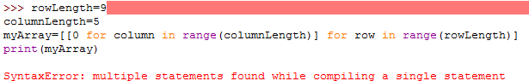

Amend the program as shown below which assigns values within the array. Run the program. What happens and why?

rowLength=9

columnLength=5

myArray=[[0 for column in range(columnLength)] for row in range(rowLength)]

myArray[0][5] = 99

myArray[2][3] = 74

print(myArray)

Make the following changes to the program which will print out the array a row at a time. Explain how it works.

rowLength=9

columnLength=5

myArray=[[0 for column in range(columnLength)] for row in range(rowLength)]

myArray[0][4] = 99

myArray[2][3] = 74

# print out a row at a time

for row in range(rowLength):

print(myArray[row])